Trivia Game

Create an application where users can play a trivia game. Users can also add new questions that can be added to the game.

Use Angular and use Express MVC as the backend. Make sure that you also integrate and save the data to MongoDB.

Question {question: "aaaaaaaaaaaaaaaaaaaa", answers: Array(3)}answers: Array(3)0: Answer {isCorrect: true, answer: "gggggggggggggggggg"}1: Answer {isCorrect: false, answer: "ssssssssss"}2: Answer {isCorrect: false, answer: "ddddddddddddd"}length: 3__proto__: Array(0)question: "aaaaaaaaaaaaaaaaaaaa"__proto__: Object

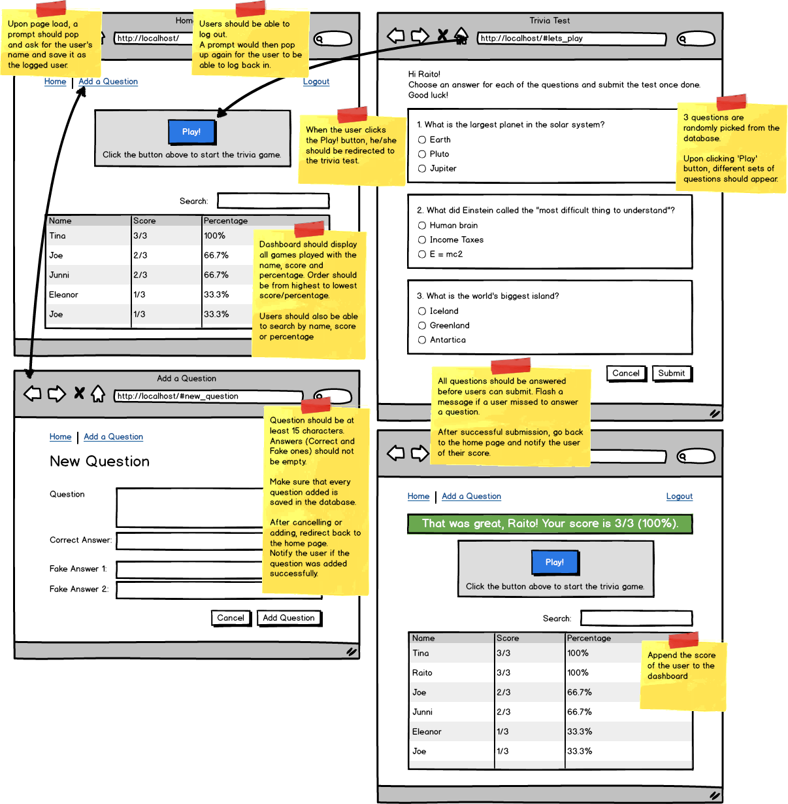

Required Features:

* Login and logout.
* Display all the games played with complete information: name of user, score, percentage. Search feature should also be implemented here.
* Ability to add a new question. Form should have validation
* Have at least 5 questions saved in the database. When users play, randomly pick 3 questions from the database.
* For the game (test), have a validation that would check if there is an answer for each for the question.
* You must be able to deploy your work to Amazon EC2 and provide the IP address or subdomain/domain name to where your work has been deployed. Please note that Heroku deployment is not honored.

Submission Requirement: Your code, a text file with the IP address or subdomain/domain name for the deployed work and short video demo link.

Note:

* The wireframe is available for download [here](https://s3.amazonaws.com/General_V88/boomyeah2015/codingdojo/curriculum/content/chapter/b_trivia.png) .
* Create a 2-3 video showing what you have built. On the video, show the functionality of the page you have built. You may download a trial version of Jing or Snag-it or Quicktime for video creation. You may save it on Dropbox public folder and copy the public link.
* To prevent other students from copying your work, please make sure your video demo is set to unlisted or with a password, and code is not saved on GitHub.
* To minimize score deduction, please make sure you upload the complete requirements (database file, video demo).
* If you are having trouble uploading files on the Exam App, please DO NOT unlock another exam. Please email the file to remote-instructors@codingdojo.com and CC your instructor.